Personalized Document Reranking Using Web Crawling and User Behavior
Ishaan Pathak
Date: 5/4/2025

Table of Contents
Introduction
Dataset Overview
Model Building Phase
Web Crawler Phase
User Behavior Simulation
Behavior-Aware Reranking
Live Query Pipeline
Code Modules Overview
System Architecture Diagram
Evaluation
Related Work
Conclusion and Future Work
References

1. Introduction
In modern search engines, traditional keyword matching often fails to deliver user-specific personalized results. This project aims to address this limitation by integrating deep learning reranking models with user behavior-based personalization techniques. The developed system operates in real time, offering relevant and tailored search results.

2. Dataset Overview
The TREC Deep Learning Track 2023 dataset was used, consisting of queries, top-100 candidate documents, and relevance judgments. We processed and used a subset of 100,000 query-document pairs due to resource constraints, extracting document texts from the MS MARCO corpus.

3. Model Building Phase
We built the reranker using the msmarco-distilbert-base-v4 model. Each input consisted of a [query, document] pair, fine-tuned using Binary Cross-Entropy loss with AdamW optimization.
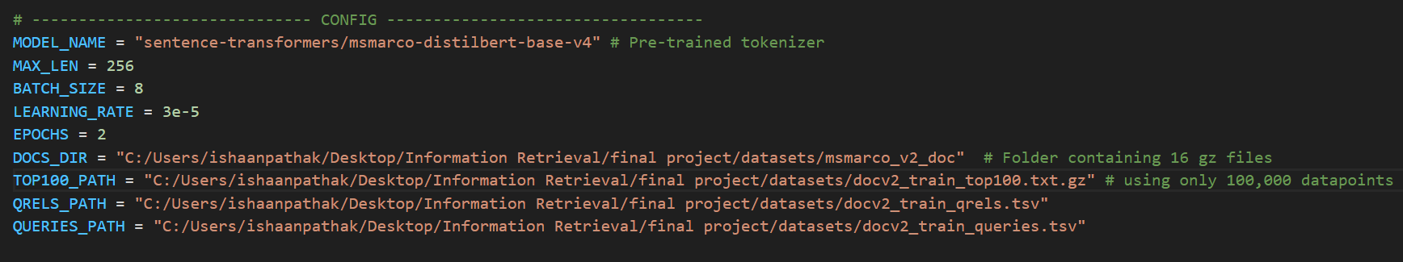
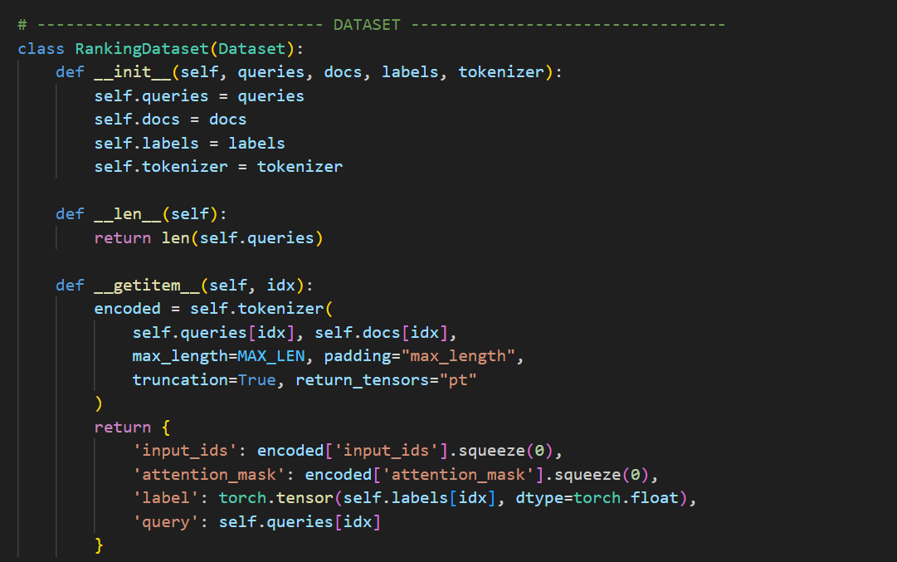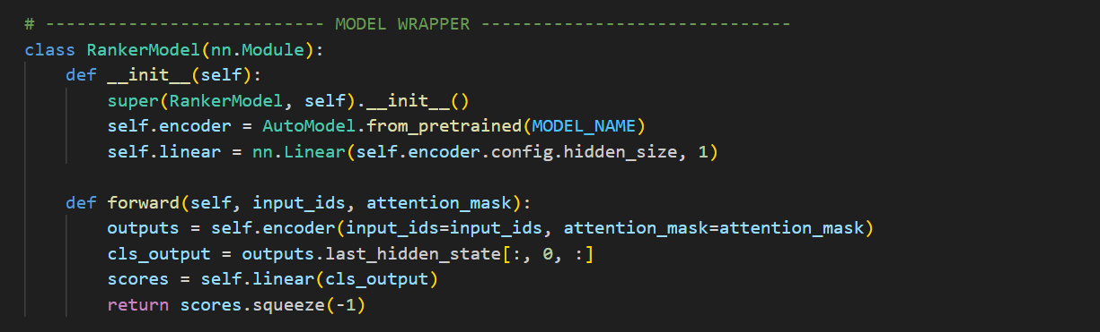
Figure 1: Screenshot of Config, Dataset and RankerModel Class
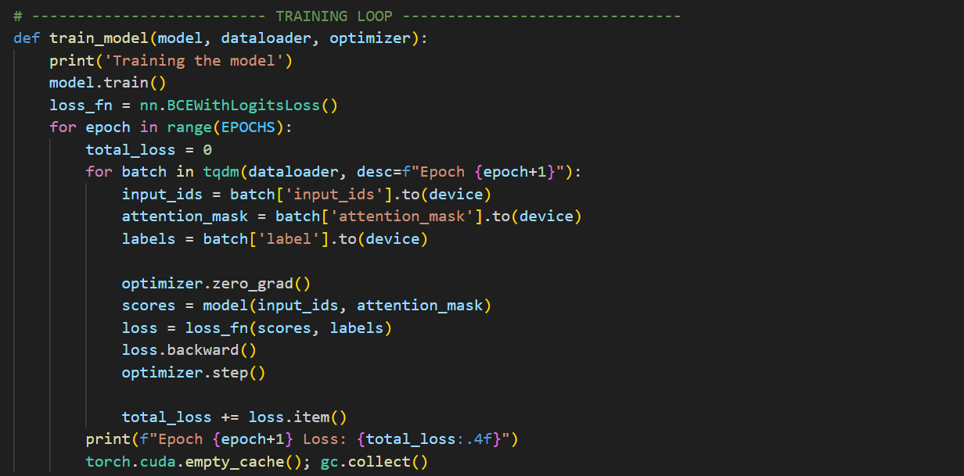
Figure 2: Screenshot of Training Loop Function
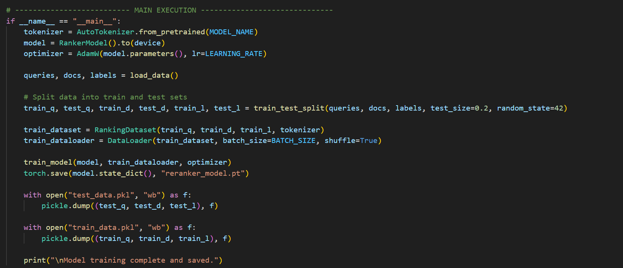
Figure 3: Screenshot of Main Loop Function

4. Web Crawler Phase
A Python-based web crawler was developed. It starts from a Wikipedia seed URL derived from the user query, fetches linked pages, and extracts textual content using BeautifulSoup.
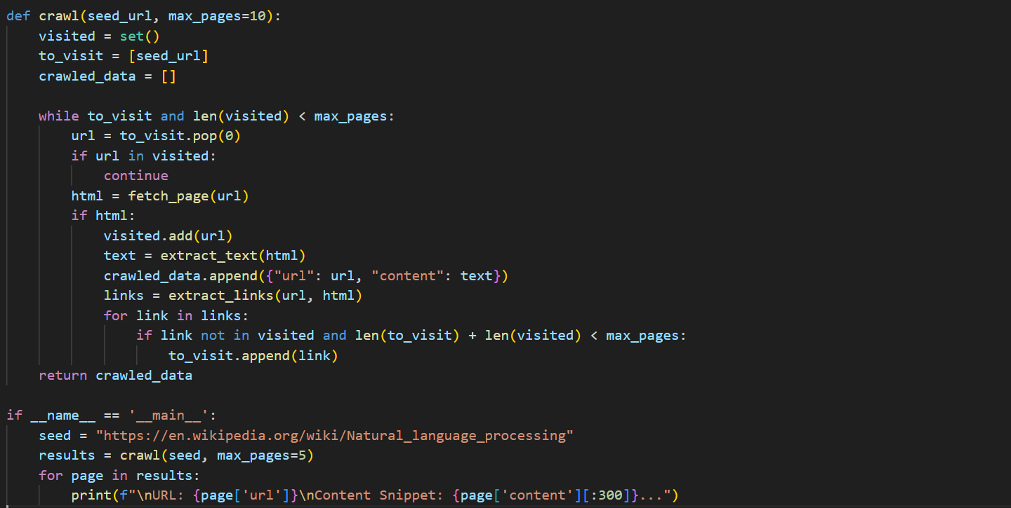
Figure 4: Screenshot of crawl() Function

5. User Behavior Simulation
Synthetic user behavior logs were generated, containing past queries and clicked documents. These logs help simulate real user behavior for behavior-aware personalization.
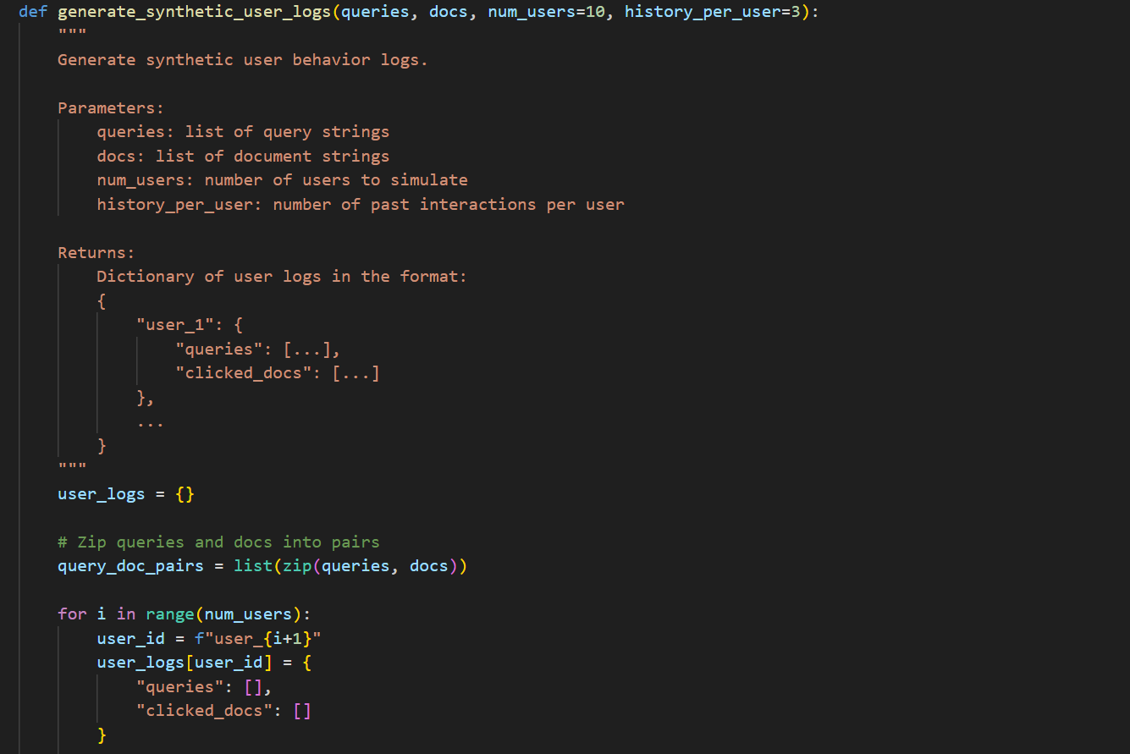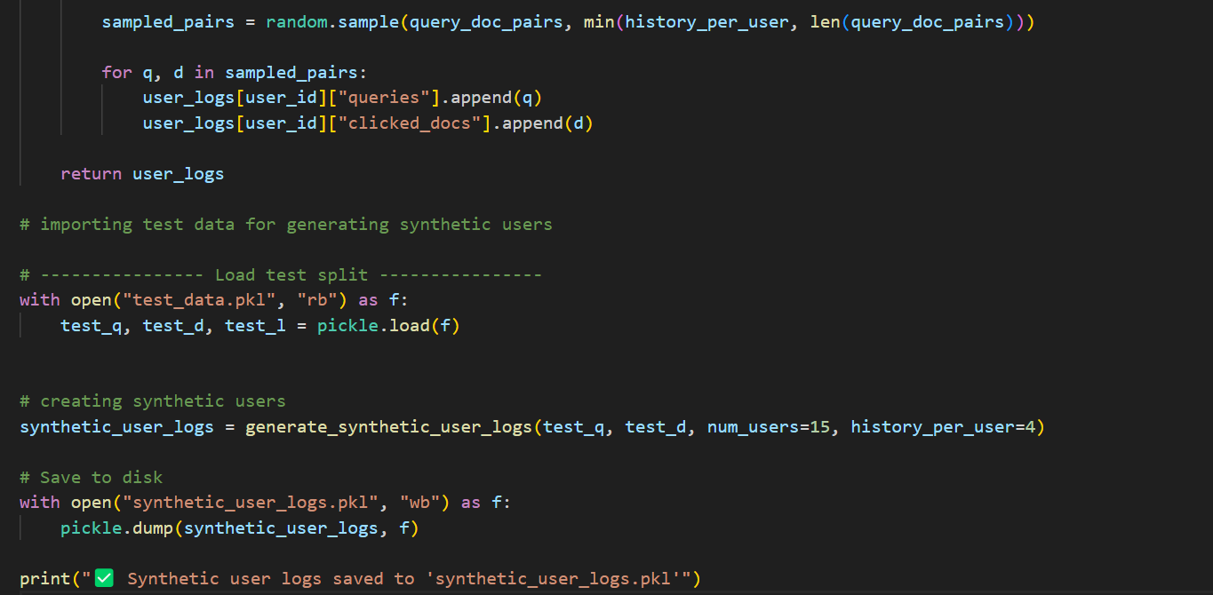
Figure 5: Screenshot of user behavior simulation data structure

6. Behavior-Aware Reranking
The system computes query embedding similarity with historical user embeddings. If a user with sufficient similarity is found, the documents clicked by that user are boosted during reranking.
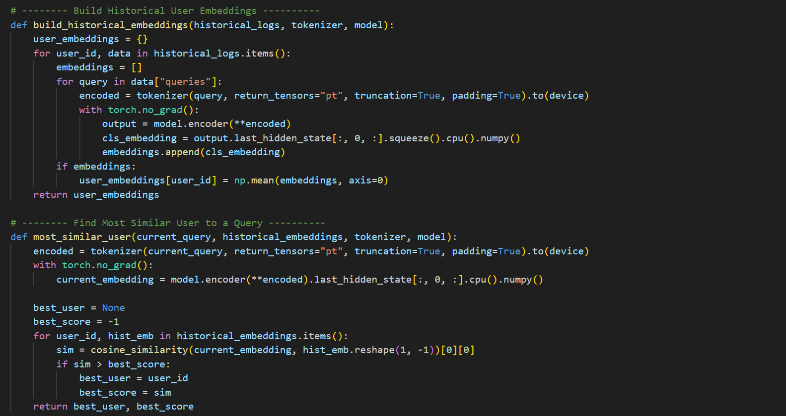

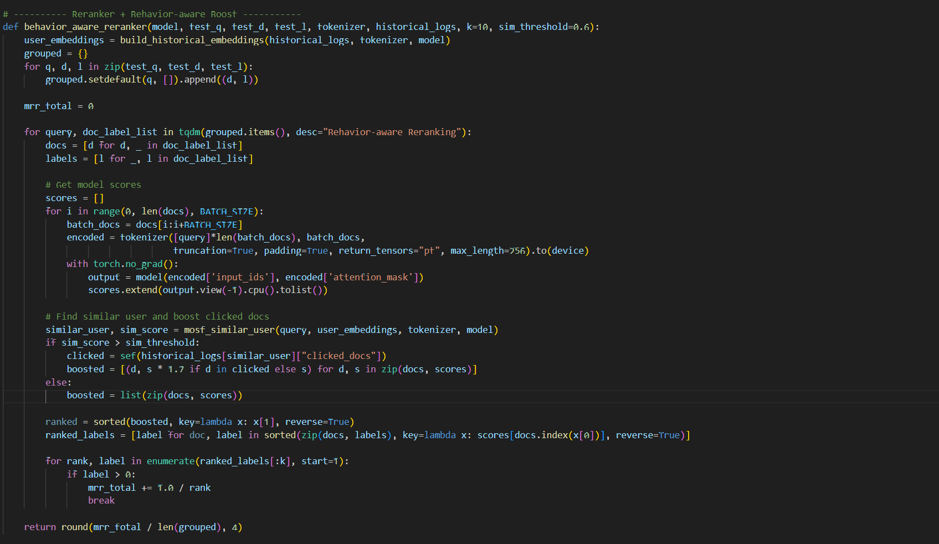
Figure 6: Screenshot of user_behavior_similarity() and behavior_aware_rerank_semantic() Functions

7. Live Query Pipeline
The full real-time pipeline takes user queries, crawls relevant pages, reranks documents, applies behavior-aware boosting if applicable, and displays the Top 5 most relevant results.
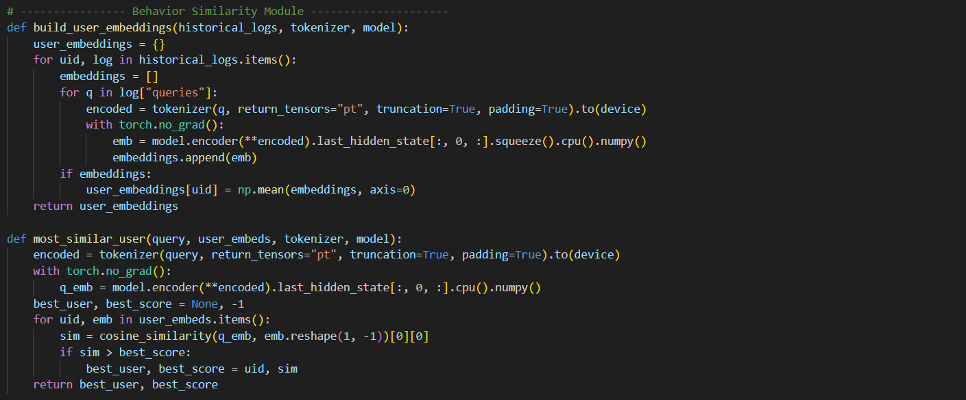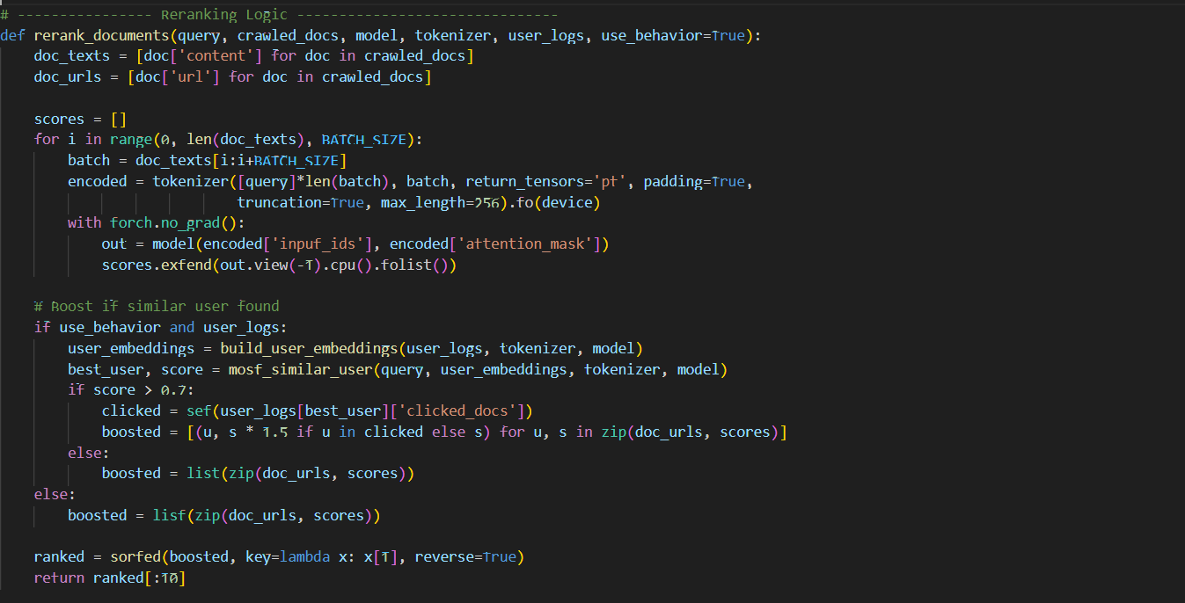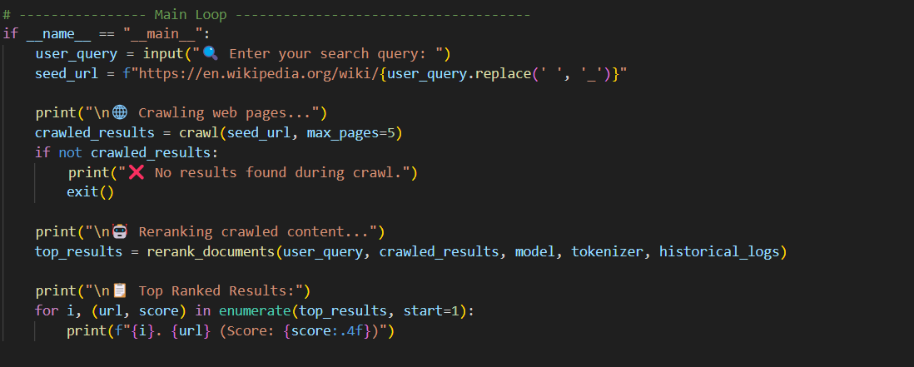
Figure 7: Screenshot of live query pipeline main function

8. Code Modules Overview
- Data Loading & Preprocessing Module: Loads queries, qrels, top-100 BM25 results. Resolves qid mismatches and extracts document content.
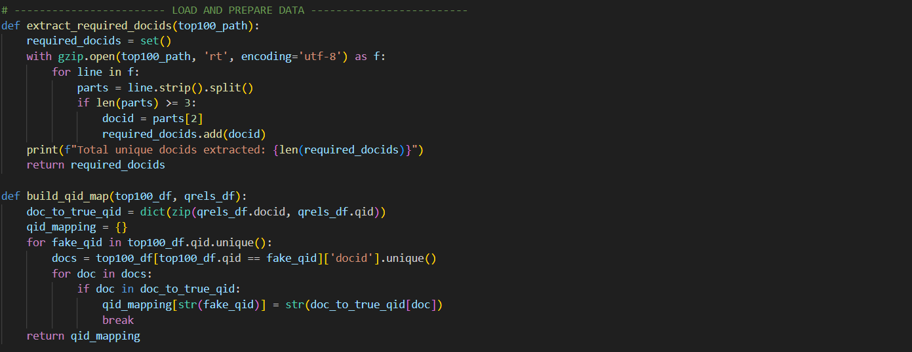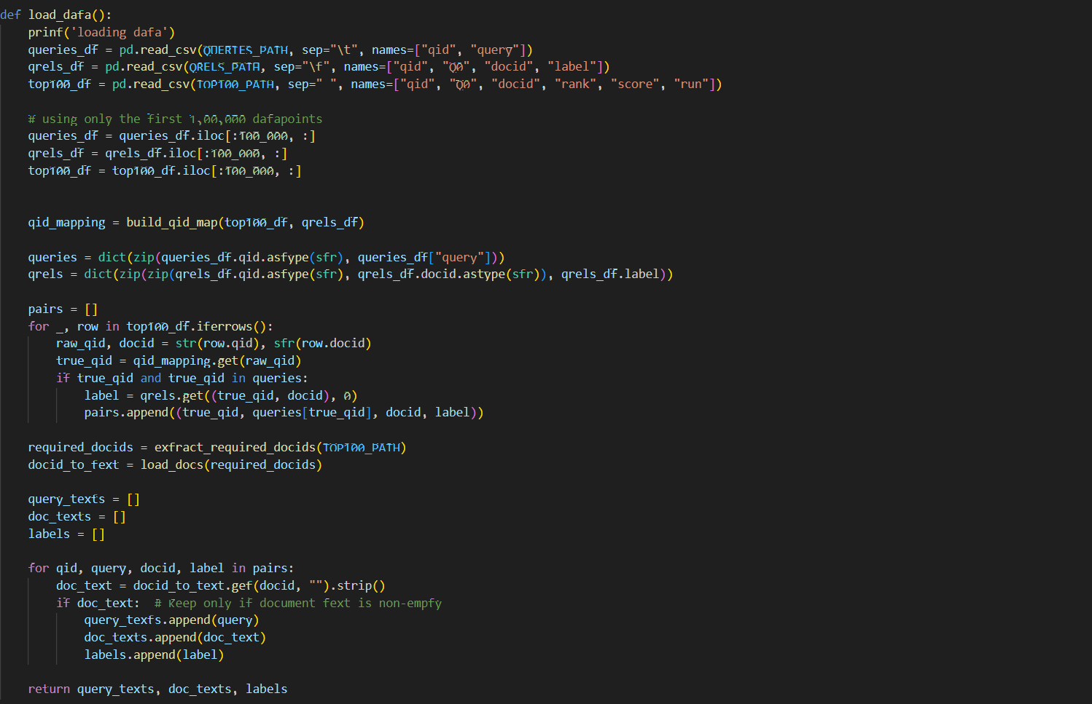
Figure 8: Screenshot of Data loading and qid mapping
- Evaluation Module: Uses MRR@10 to evaluate ranking quality.
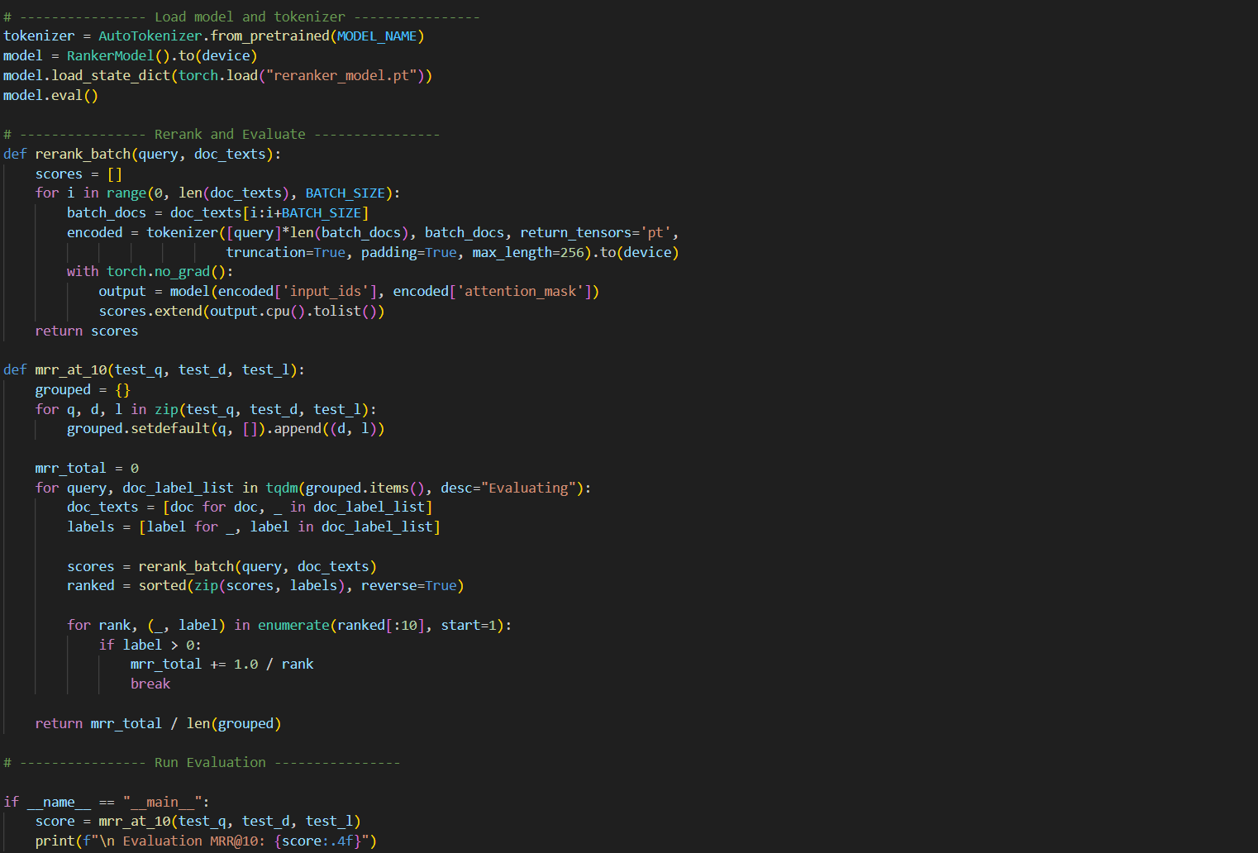
Figure 9: Screenshot of Evaluation script
- Web Crawler Module: Scrapes Wikipedia and linked content.
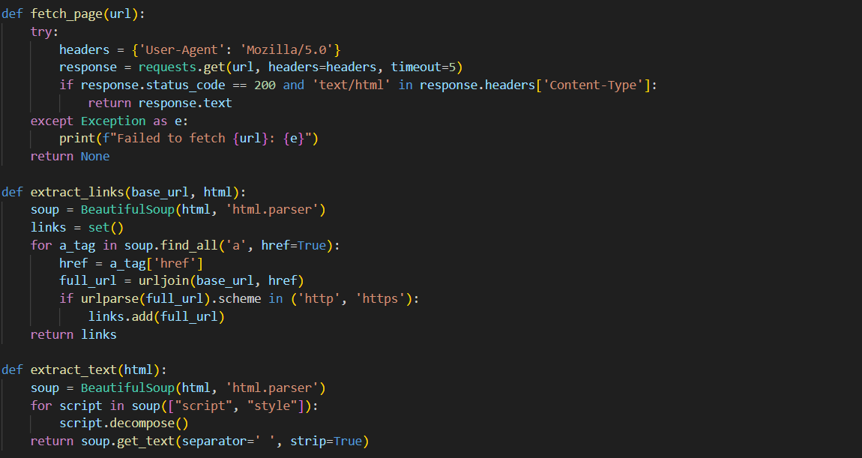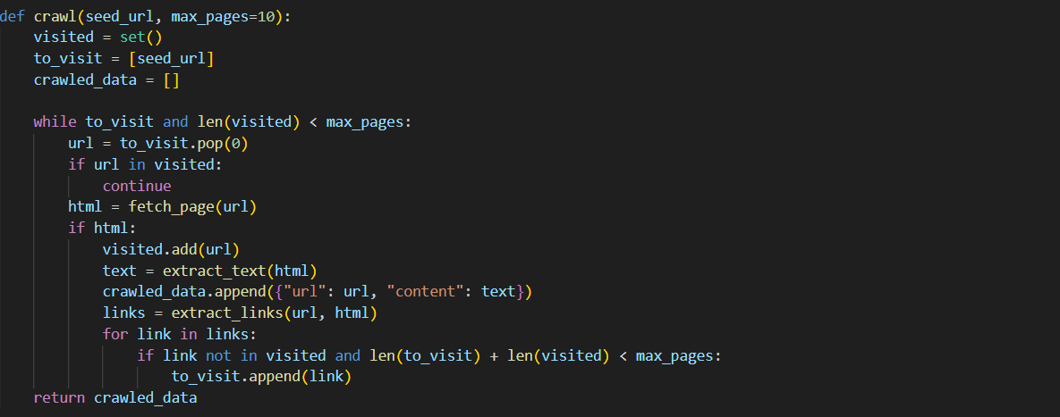
Figure 10: Screenshot of BeautifulSoup logic
- Live Pipeline Integration: Connects all modules.
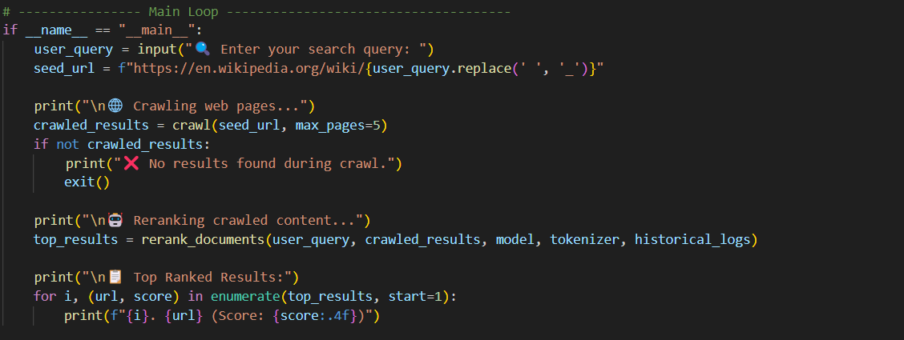
Figure 11: Screenshot of full system integration

9. System Architecture Diagram

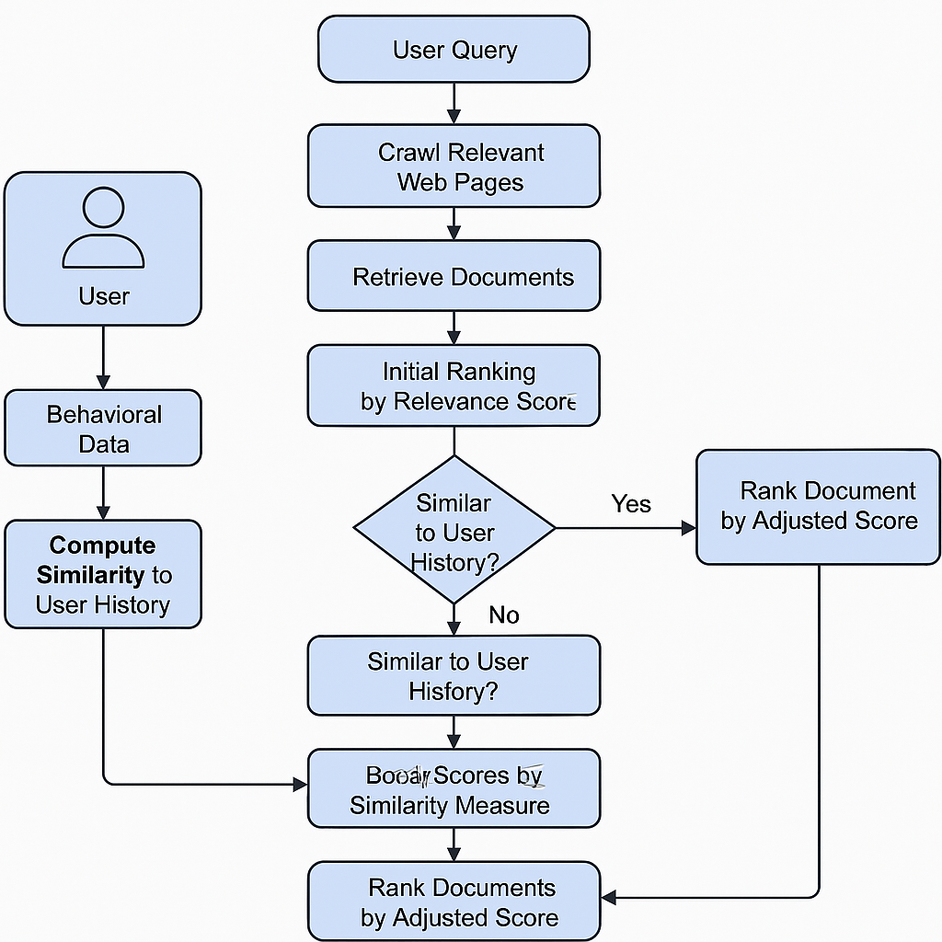

Figure 12: System Architecture Diagram (Top 5 Results)

10. Evaluation
Model performance was evaluated using MRR@10. A score of 1.0 means the relevant doc is at the top. The baseline reranker achieved ~0.0406. Similar performance was observed in behavior-aware reranker due to synthetic logs.

11. Related Work
Beel et al. (2013): Personalized reranking using content + user behavior.
Pant et al. (2004): Web crawling influenced by browsing patterns.
Zhao et al. (2019): Embedding-based re-ranking with user history.

12. Conclusion and Future Work
This project successfully built a personalized reranking system. Future work includes:
- Integrating real user logs
- Deploying via a web interface
- Enhancing personalization with topic modeling

13. References
Beel, J., et al. (2013). Personalised Reranking of Paper Recommendations Using Paper Content and User Behavior. JCDL.
Pant, G., et al. (2004). User Browsing Behavior-Driven Web Crawling. WIAS.
Zhao, W. X., et al. (2019). Personalized Re-ranking for Recommendation. arXiv:1904.06813

